Laptop Recommendation Expert System
Forward Chaining Rule-Based Reasoning
Introduction
This project implements a simple expert system that recommends laptop types and technical specifications based on user preferences. The system uses forward chaining, a data-driven reasoning method that starts from known facts (user answers) and applies IF–THEN rules to derive conclusions. The goal of this project was to demonstrate how rule-based reasoning can be applied to simulate expert decision-making for selecting suitable laptops based on user requirements.
Project Overview
The expert system was developed in Python using a modular design. The program collects user inputs such as budget, usage type, preferred operating system, and travel habits, and infers either a laptop recommendation or hardware specifications. The reasoning process is completely automated and transparent, showing how each conclusion is derived from the rule based.
System Components
During implementation, I worked across multiple files to complete the expert system and make it fully functional. The main updates I made are summarized below:
- engine.py – I implemented the main inference logic by completing the can_fire, run, and conclusions functions inside the ForwardChainingEngine class. These updates allow the engine to check rule conditions, fire applicable rules, record the reasoning trace, and produce organized results for recommendations and specifications.
- kb_loader.py – This file was already functional. I verified the JSON loading process and confirmed that it correctly maps the IF–THEN rules from the knowledge base into Rule objects used by the engine.
- kb/laptop_rules.json – I expanded the knowledge base by adding nine new rules in addition to the original one provided. In total, the file now contains ten complete and logically distinct rules that cover a variety of laptop recommendation and specification scenarios.
- main.py – I implemented the overall program flow. This included collecting user inputs through yes/no questions, asserting the gathered facts into the engine, executing the inference process, and printing the final results along with their explanations. I also added explanation lines for both recommendations and specifications to make the reasoning fully transparent.
- tests/test_cases.py – I developed a separate Python test script to automate the verification of all ten rules. Each test defines a specific set of input facts and checks whether the expected recommendation or specification is correctly inferred.
- tests/README.txt – I documented each test case in this file, listing the input facts and expected outputs in a simple readable format that matches the professor’s instructions.
Knowledge Base
The knowledge base consists of ten rules that cover different user scenarios. Each rule includes a list of antecedents (conditions) and a consequent (result). The rules are organized by priority, so that key recommendations are evaluated before supporting specifications.
- High budget, portability, and long battery life → recommend premium_ultrabook
- Low budget, office use, and portability → recommend budget_ultrabook
- Gaming with a medium budget → recommend midrange_gaming_laptop
- Gaming with a high budget → recommend high_end_gaming_laptop
- Creative work and portability → spec ram_16_plus
- Creative work and large screen → spec display_15_plus_color_accurate
- Frequent travel and long battery life → spec battery_60wh_plus
- Preference for macOS → spec macos_required
- Linux preference and office work → spec linux_friendly_hw
- Need for AI acceleration → spec gpu_with_tensor_cores
Inference Process
I implemented the forward chaining process in the run function of the inference engine. The program begins by taking a set of initial facts gathered from the user through the command-line questions. Using these facts, the engine repeatedly checks each rule to determine whether its conditions are fully satisfied.
When all the conditions for a rule are met and its conclusion is not already known, the rule fires and its conclusion is added to the fact base. This process continues automatically until no additional rules can fire. Each time a rule fires, the system records the rule name and the newly inferred fact in the trace list. This trace information is later used to explain how each conclusion was reached.
Explanations
I enhanced the explanation feature so that the system now clearly displays the reasoning behind both recommendations and specifications. After each rule fires, the program looks up the rule that produced the result and prints an explanation line identifying it. This addition makes the output more transparent and helps users understand exactly which rule contributed to each conclusion.
Example output:
Recommendation: premium_ultrabook
Explanation: derived from rule 'Premium Ultrabook'
Specification: ram_16_plus
Explanation: derived from rule 'Creative Work RAM Requirement'
Results
To verify correctness, all ten rules were tested individually using both the interactive interface and the automated test script. For each test, the input facts were selected to match one specific rule, and the resulting output was compared with the expected recommendation or specification.
All ten scenarios produced correct and consistent outputs. The test results are included below for reference.
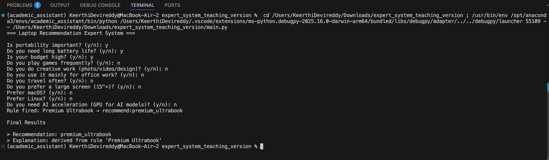
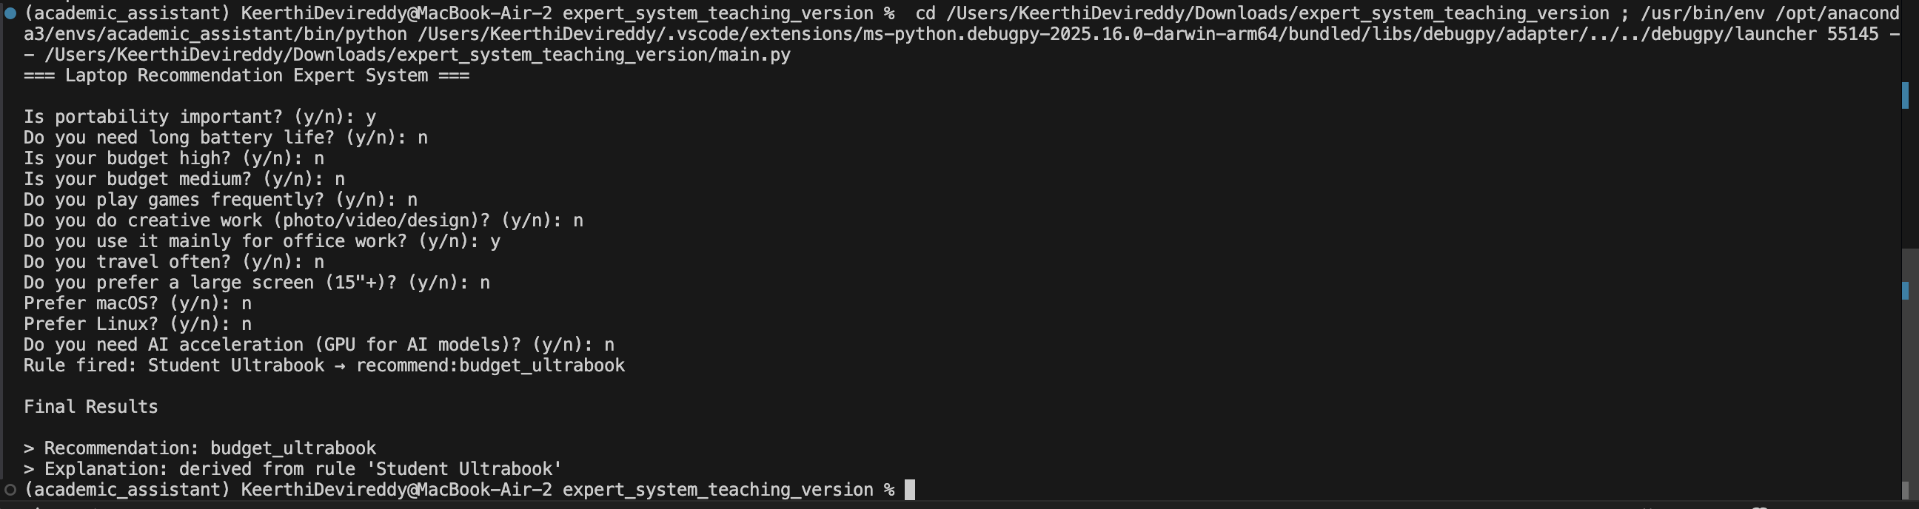
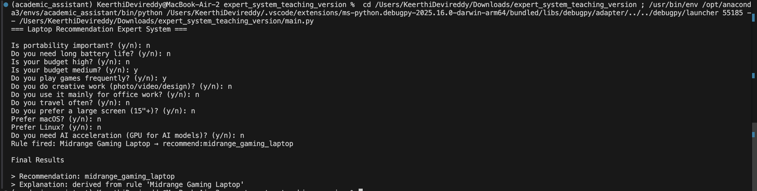
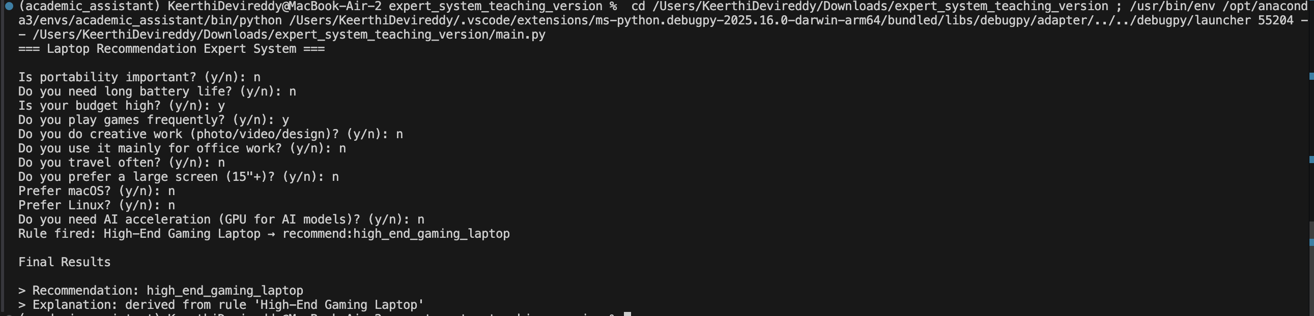
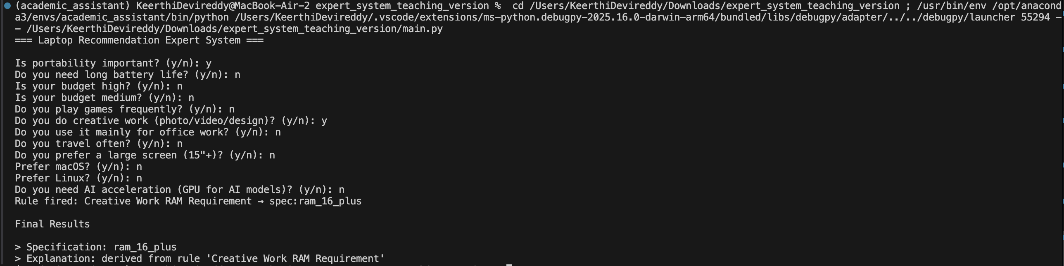
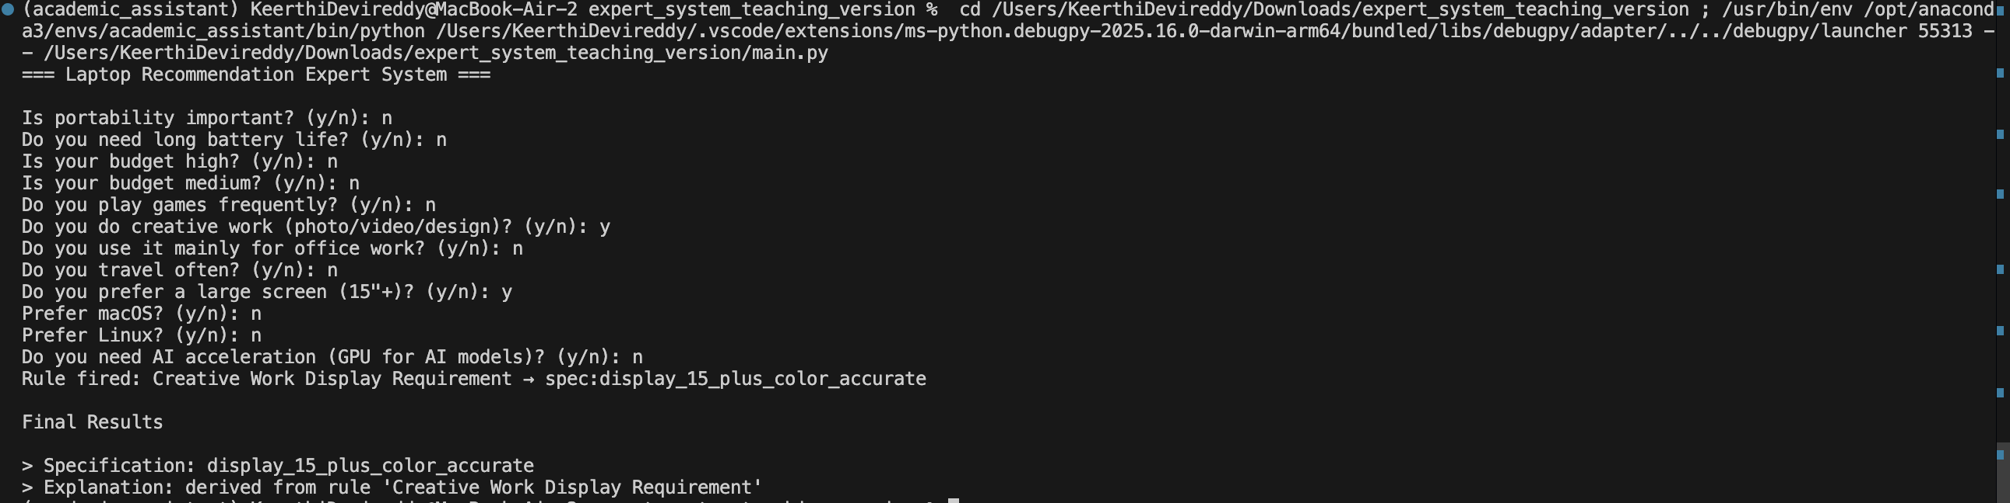
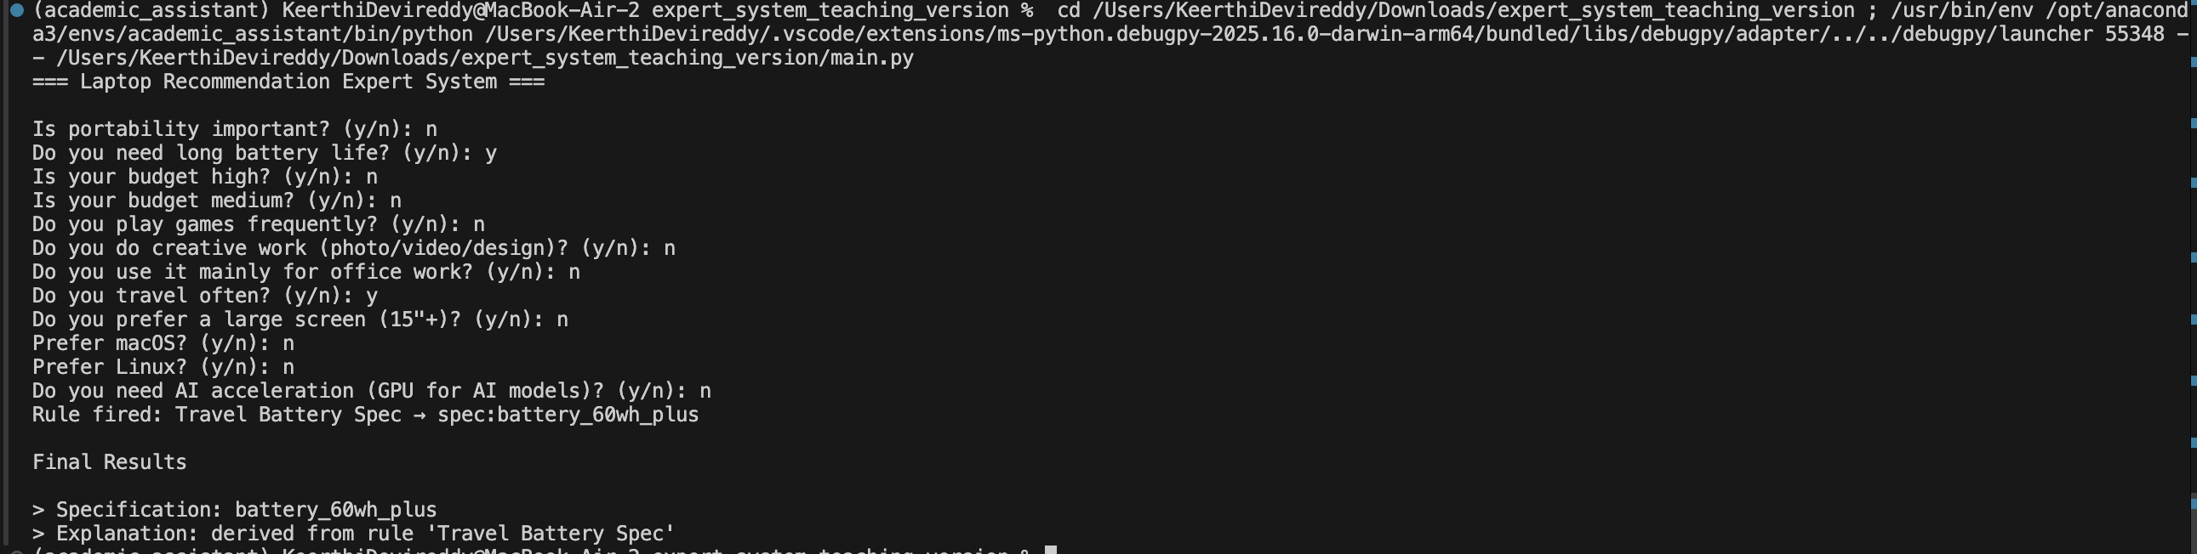
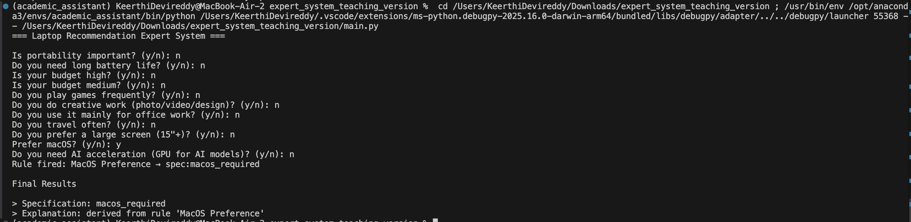
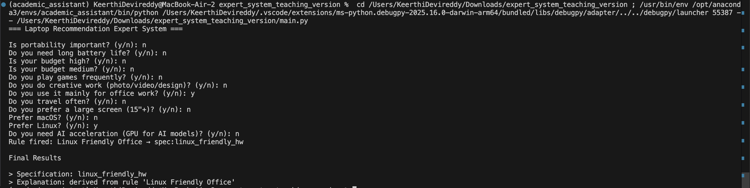
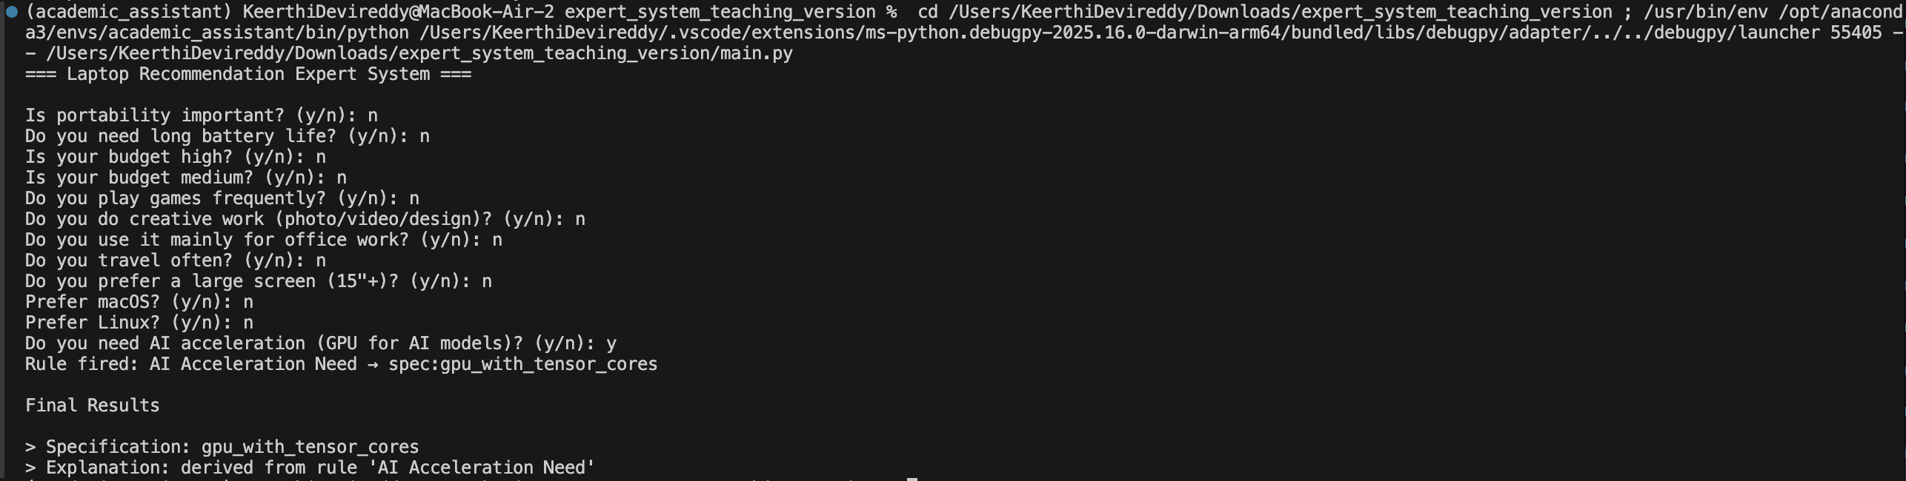
And the below is the result of the automates testing script present in the tests folder:
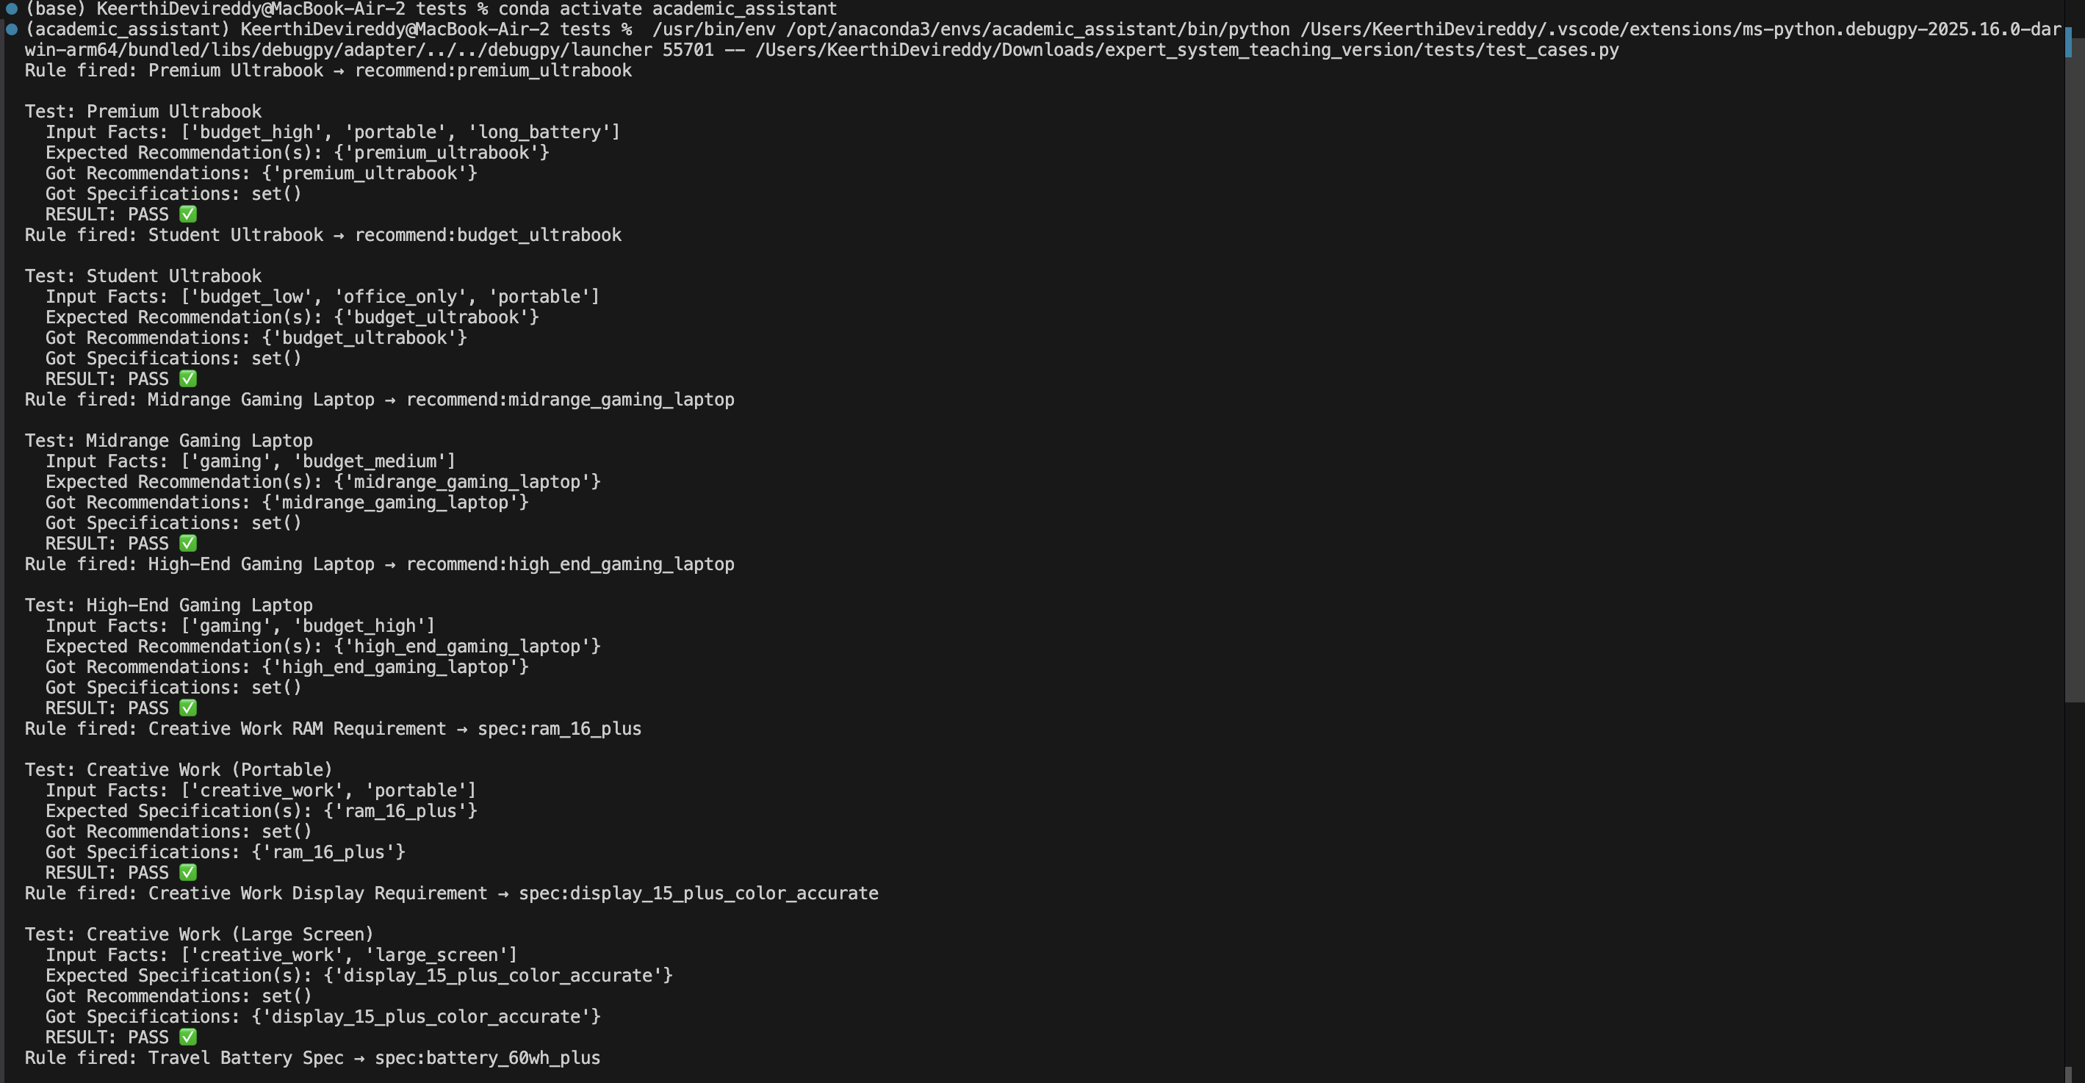
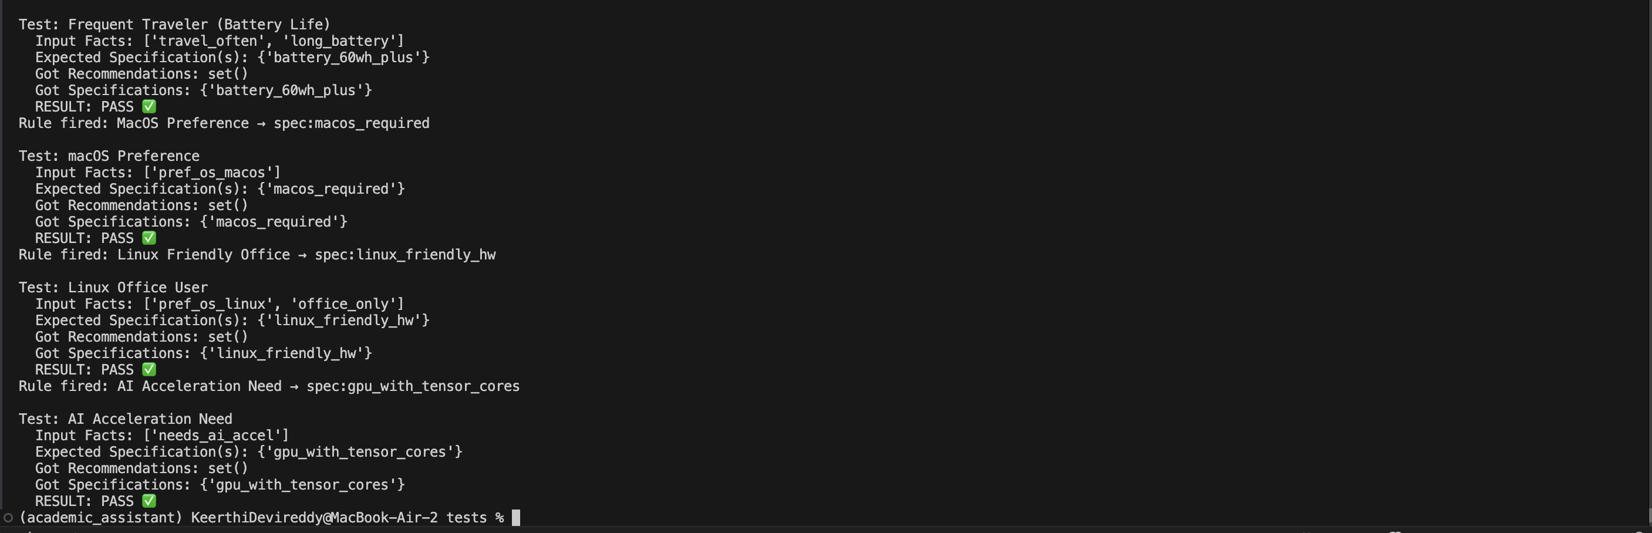
Conclusion
The laptop recommendation expert system applies forward chaining to generate meaningful laptop suggestions from user preferences. All ten rules fired as expected, and every recommendation was supported by a clear explanation of its origin.

